Design an obstacle detector and distance measuring device

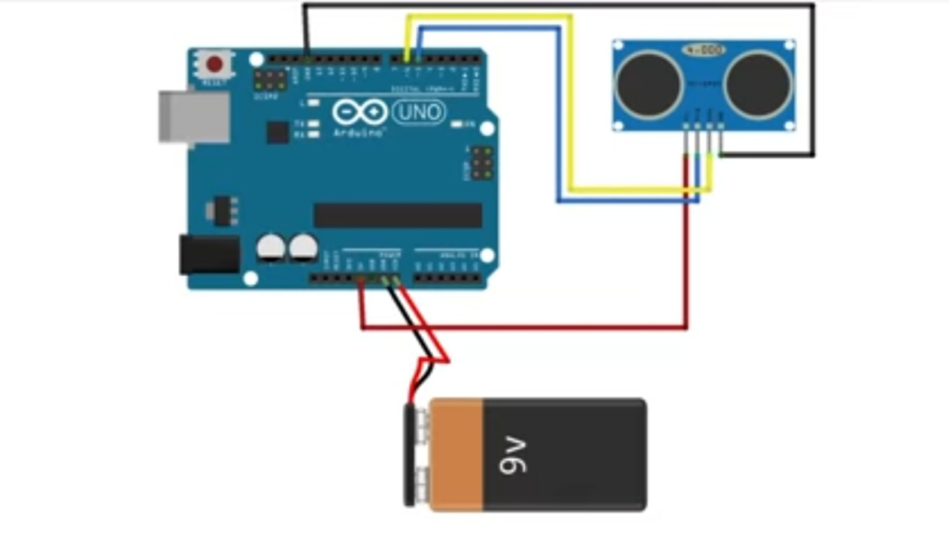

THEORY

Concept used :- we have used ultarasonic sensor sensor here for measuring the distance by distance formula

Distance=duration\*0.034/2

Observation :- we have observe that by giving less delay time to the sensor we can have more accuracy in circuit

Problem and troubleshooting :- the main problem was it was not giving correct value at the time when sensor was at that place so, we decress the delay in sensor

Precaution :- ultrasonic sensor is to sensitive equipment so we have to use it properly

Learning outcome:- by doing this activity I came to know that how we can make parking sensor by ourself